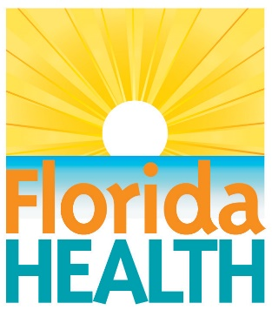
April 3, 2017
FLORIDA DEPARTMENT OF HEALTH IN GULF CELEBRATES NATIONAL PUBLIC HEALTH WEEK – THE FLORIDA WAY
Contact:
Sarah Hinds, PIO
Sarah.Hinds@flhealth.gov
850-227-1276
Port St. Joe, Fla. – This week is National Public Health Week and the Florida Department of Health in Gulf County is giving Floridians an inside look at some of the careers behind public health and the dedicated professionals who do them. Each day, the department will highlight a different area of public health including epidemiology, emergency preparedness and response, environmental health and public health nursing. These fields and many more help the department carry out our mission to promote, protect and improve the health of Florida residents and visitors.
"In Public Health, we work to ensure conditions where everyone has an opportunity to be healthy- where they live, learn, work and play”, said Marsha Lindeman, Administrator for the Florida Department of Health in Gulf and Franklin Counties. “Our focus is on prevention. While a doctor treats people who are sick, those of us working in public health try to prevent people from getting sick or injured in the first place. Gulf County staff work behind the scenes and on the front lines to prevent diseases, promote health policies and encourage healthy behaviors.”
Last year, the department was the first state in the nation to receive national accreditation as an integrated department of health through the Public Health Accreditation Board (PHAB). Accreditation by PHAS signifies that the department, including the state health office and all 67 county health departments, is meeting national standards for ensuring essential public health services are provided in the community.
For the next two years, the department will focus on several key areas to improve health in our state including increasing childhood vaccination rates, achieving health equity in all communities, developing a high quality trauma service, reducing HIV infection rates, reducing infant mortality rates, decreasing inhaled nicotine use and decreasing licensure processing time for health care professionals.
Use #ThankAPublicHealthPro on Twitter, Facebook and Instagram to recognize a public health professional in your area during National Public Health Week.
For more information about National Public Health Week, please visit www.nphw.org. For more information about the different programs and services offered at DOH-Gulf, please visit gulf.floridahealth.gov or call (850) 227-1276.

About the Florida Department of Health
The department, nationally accredited by the Public Health Accreditation Board, works to protect, promote and improve the health of all people in Florida through integrated state, county and community efforts.
Follow us on Twitter at @HealthyFla and on Facebook. For more information about the Florida Department of Health, please visit www.FloridaHealth.gov.
.

